January 2020 Arc Aid Thrift Store 653 19th St. W. Dickinson, ND 58601
Sunday | Monday | Tuesday | Wednesday | Thursday | Friday |  | Saturday
29 | 30 | 31 | 1 | 2 | 3 |  | 4
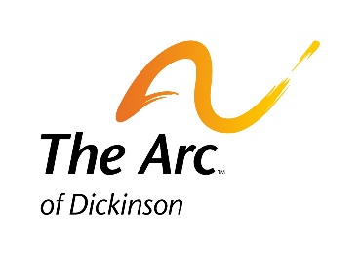 |  | 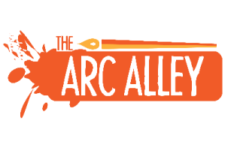 | Store closed for the Holiday and for Annual Cleaning
5 | 6 | 7 | 8 | 9 | 10 |  | 11
Store Hours  Mon – Friday 9-5  Saturdays 9-4  701-483-2723 | Buy one sweater get one of equal or less value free!. | All $.25, $.50, and $1.00 Books  10 for a Dollar (Excludes all books priced more than $1.00) | Women’s Shoes and Men’s Boots  under $20  25% | Senior (65 and Older) & Military Day  25% Off  items under $20 | Pillows, Tablecloths and Curtains  25% Off |  | Visit the Arc Alley North Entrance Winter Hours Tuesday, Friday & Saturday 10:00 – 4:00
12 | 13 | 14 | 15 | 16 | 17 |  | 18
New merchandise added daily!  Find that hidden  treasure! | Pictures, Picture Frames and Photo Albums 25% Off | DVD’s 5 for $2.00  Does not include  Blu Ray | Wood items 25% Off | Senior (65 and Older) & Military Day  25% Off  items under $20 | First Five Friday!  First five items under $10.00 only  a dollar each! |  | Thank-you for your generous support and donations.
19 | 20 | 21 | 22 | 23 | 24 |  | 25
We do not receive state or federal funding. Thank-you for your great donations | Martin Luther King Day  Item of your choice under $20  25% Off | Purses, Bags, and Totes under $20.00 25% Off | Women’s Hoodies and Sweaters  under $20.00  25% Off | Senior (65 and Older) & Military Day  25% Off  items under $20 | All $.25, $.50, and $1.00 Books  10 for a Dollar (Excludes all books priced more than $1.00 |  | Become a member of The Arc. Ask for Membership Application at counter or go on line
26 | 27 | 28 | 29 | 30 | 31 |  | 1
 | Pillows and Bedding under $20  25% Off | Glassware and Vases 25% Off | Pictures, Picture Frames and Photo Albums 25% Off | Senior (65 and Older) & Military Day  25% Off  items under $20 | Women’s Shoes and Men’s Boots  under $20  25%
The Arc of Dickinson, Inc.

The Arc Aid Thrift Store
653 19th St. W, Unit B
Dickinson, ND 58601
701-483-2723

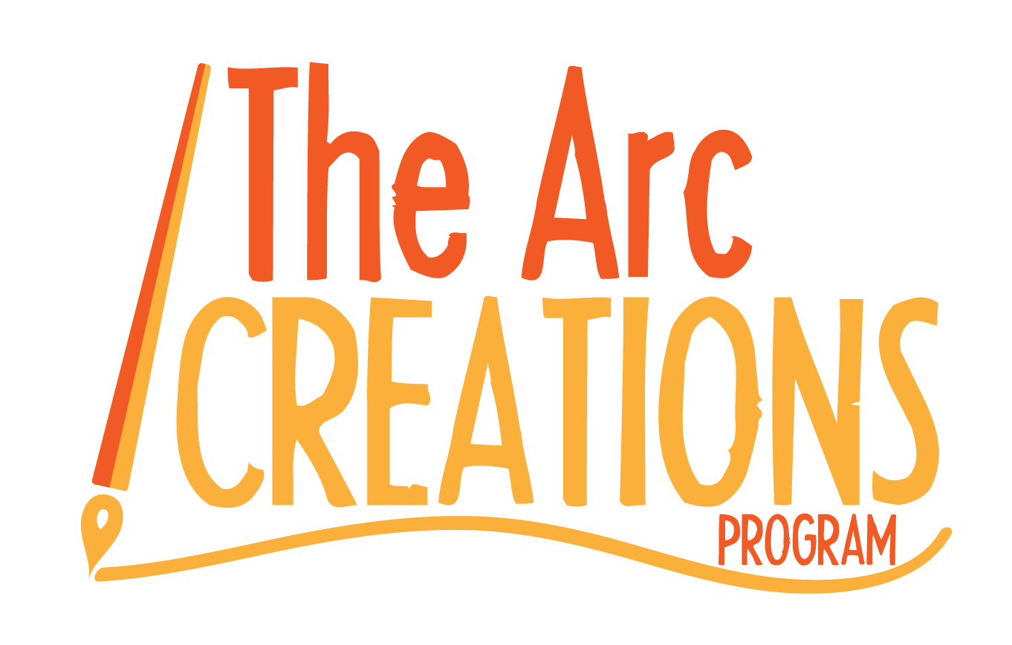
Visit the Arc Alley, by using the North Entrance
Open Tuesday, Friday and Saturday
10 AM to 4 PM
Check out our growing inventory and support individuals in their mission to accomplish their goals in creating marketable artwork!!

Mission Statement
The Arc Creations mission is to offer individuals with disabilities and/or disabling circumstances, opportunities for productive volunteering. Participants are empowered to explore their strengths, desires, work skills and vocational abilities through various methods of recreating and refurbishing products. We provide quality flexible programs and services to enhance independence, foster inclusion, promote self-advocacy and build community connections.

